
Shri Someshwar Shikshan Prasarak Mandal’s

SOMESHWAR VIDNYAN MAHAVIDYALAYA
Someshwarnagar , Tal: Baramati, Dist: Pune

PROJECT REPORT

Submitted in partial fulfilment of the requirement for the award of the degree in B.Sc. Computer Science. Of

SAVITRIBAI PHULE PUNE UNIVERSITY,
PUNE

ON
“GYM MANAGEMENT SYSTEM”
BY
Mr.Thombare Shreyash mohan
Mr.Bongane rajesh devdas
Mr.shinde manthan Parmeshwar
Mr.Tambe rushikesh Sandip

Under the Guidance of
Miss. Jagtap P. S
Miss. Kharade G. M
TY B.Sc (Computer Science)(SEM-VI) 2025-2026
CERTIFICATE
B.Sc. (CS) DEGREE OF PROGRAM IN COMPUTER SCIENCE
2025 – 2026
This is to certify that the Project Report
on
“GYM MANAGEMENT SYSTEM”
Submitted by
Mr.Tambe rushikesh sandip
Mr.Shinde manthan parmeshwar
Mr.Bongane rajesh devdas
Mr.Thombare Shreyash mohan
Has successfully submitted during the academic year 2025-2026 in the partial fulfilment of B.Sc. DEGREE PROGRAM IN COMPUTER SCIENCE under the Savitribai Phule Pune University, Pune.

Project Guide Head of Department

Internal Examiner External Examiner

INDEX

1. Introduction
2. Scope of the Project
3. Objectives
4. Hardware and Software Requirements
5. System Design
6. Advantages
7. Disadvantages
8. Features
9. Conclusion

1. Introduction

In the modern digital era, technology has become an essential part of every industry including the fitness sector. Traditional gym management involves manual record keeping which is time-consuming and error-prone. The Gym Management System is a web-based application that automates all operations such as membership handling, trainer management, and billing. It is developed using HTML, CSS, JavaScript for frontend and PHP with MySQL for backend, providing a fast and reliable system.

2. Scope of the Project

The scope of this project includes managing gym members, tracking fitness activities, and handling business operations efficiently. It provides features like online registration, plan selection, and booking system. It can be used by gym owners, trainers, and customers to improve overall experience and performance.

3. Objectives

The main objective of this system is to digitize gym operations and reduce manual work. It aims to provide secure login and registration, improve customer satisfaction, and ensure proper data management. It also helps users achieve their fitness goals like weight loss, muscle gain, and overall health improvement.

4. Hardware and Software Requirements

Hardware Requirements:
- Computer or Laptop
- Mobile Devices
- Internet Connection
- Storage Devices
Software Requirements:
- HTML, CSS, JavaScript (Frontend)
- PHP (Backend)
- MySQL (Database)
- Web Browser
- Operating System
These requirements ensure smooth working of the system.

5. System Design

The system design is represented using various UML diagrams. ER Diagram shows the relationship between database entities. Use Case Diagram represents user interactions. Sequence Diagram shows the flow of operations. Activity Diagram explains workflow and Class Diagram defines system structure. These diagrams help in better understanding and implementation of the system.

6. Advantages

The system provides many advantages such as being cost-effective and easy to use. It reduces paperwork and provides real-time updates. Users can access services anytime and anywhere. It improves efficiency, accuracy, and customer satisfaction. Maintenance is also easier compared to manual systems.

7. Disadvantages

Despite its advantages, the system has some limitations. Security can be a concern if not properly managed. It requires technical knowledge for maintenance and updates. There may be browser compatibility issues. Also, initial setup and development require time and effort.

8. Features

The Gym Management System includes several useful features:
- User Registration and Login System
- Membership Management
- Plan Description and Selection
- BMI (Body Mass Index) Calculator
- Booking and Scheduling System
- Admin Dashboard
These features make the system efficient and user-friendly.

9. Conclusion

The Gym Management System is a modern solution for managing gym activities efficiently. It reduces manual effort and improves accuracy. The system enhances user experience and provides better service to customers. In future, more advanced features like mobile application, online payment system, and AI-based fitness suggestions can be added.
ER DIAGRAM-

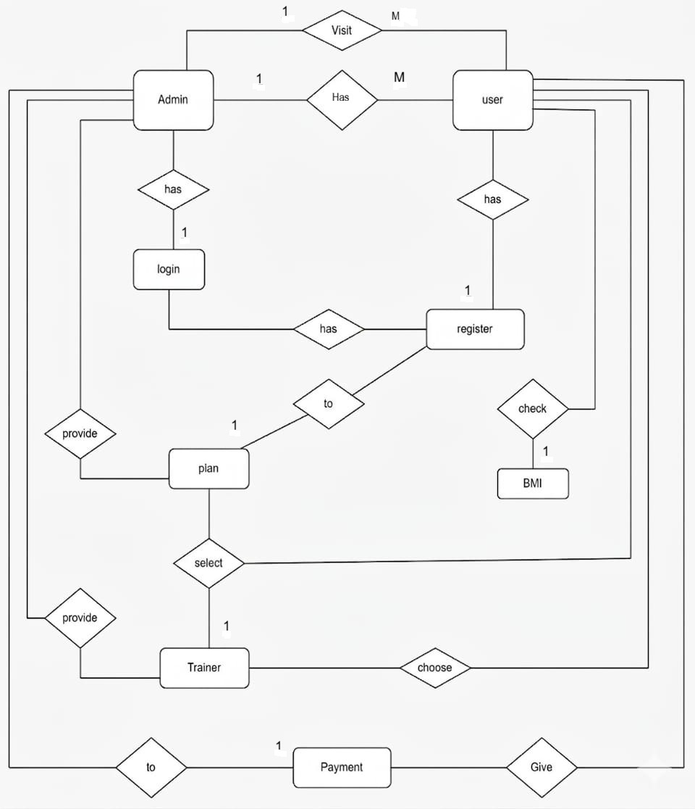

SEQENCE DIAGRAM-

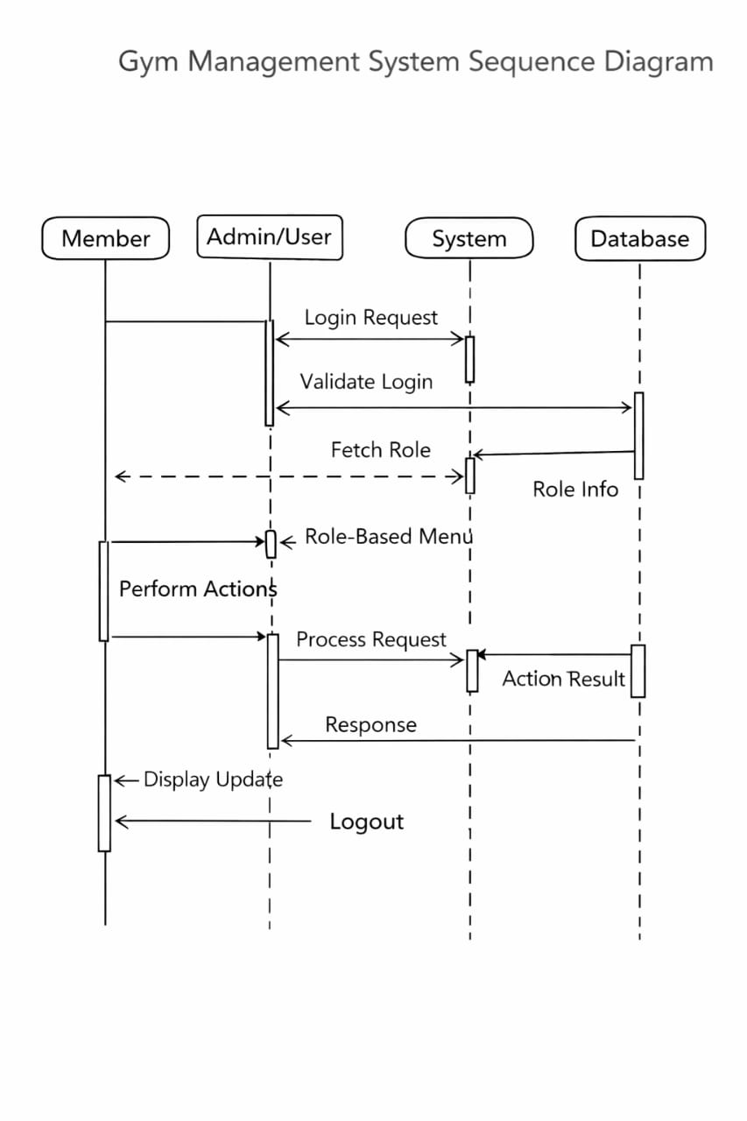

USE CASE DIAGRAM –

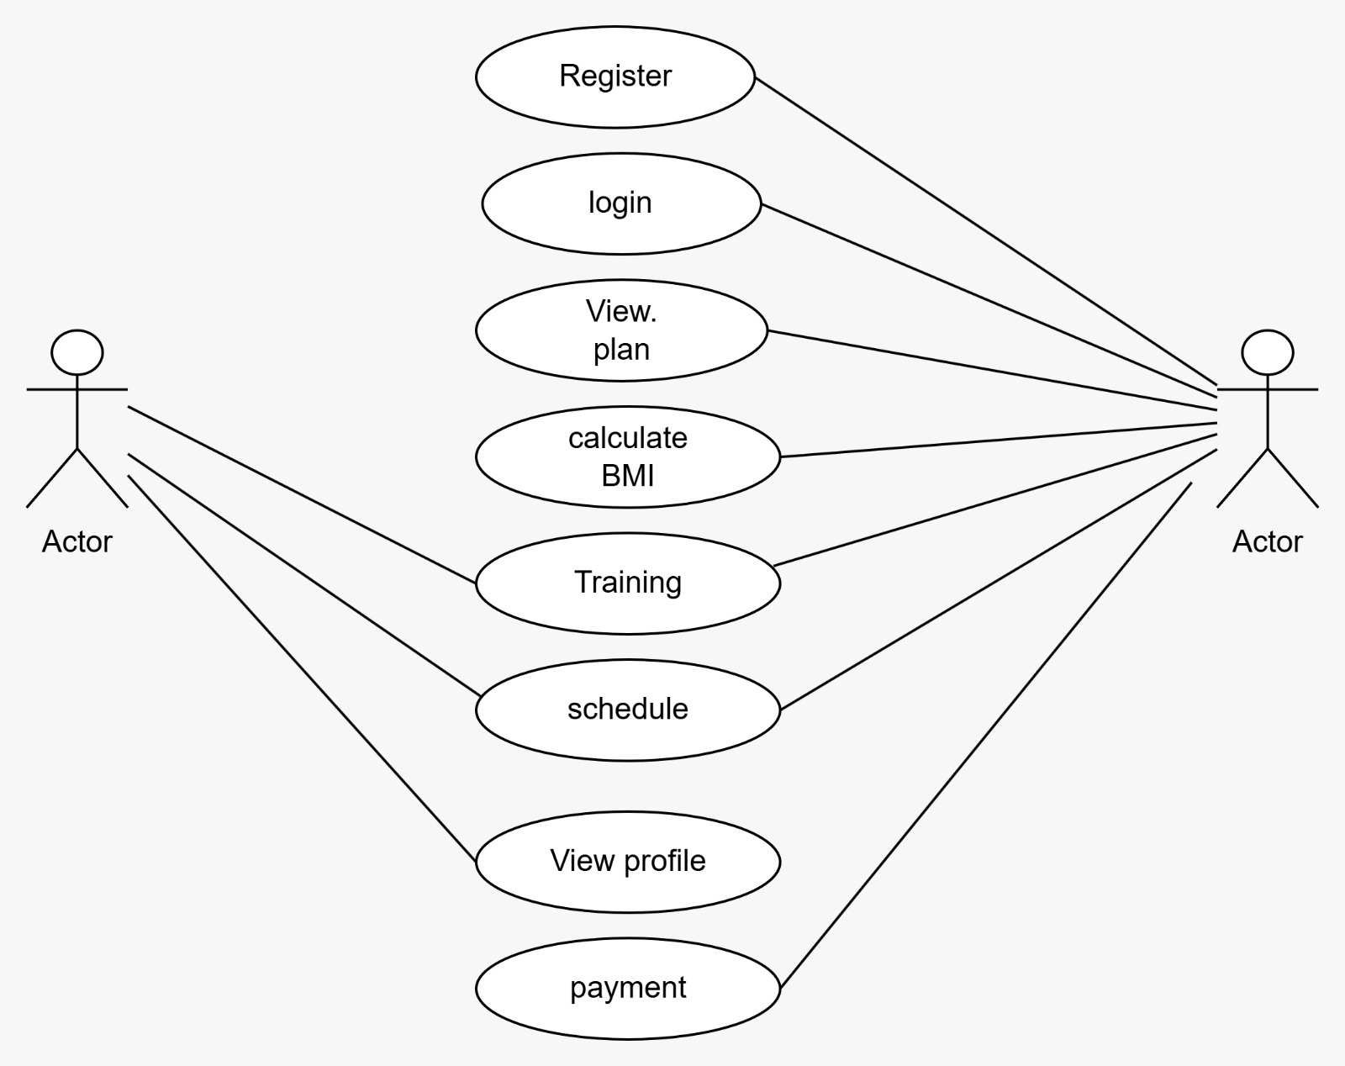

ACTIVITY DIAGRAM –

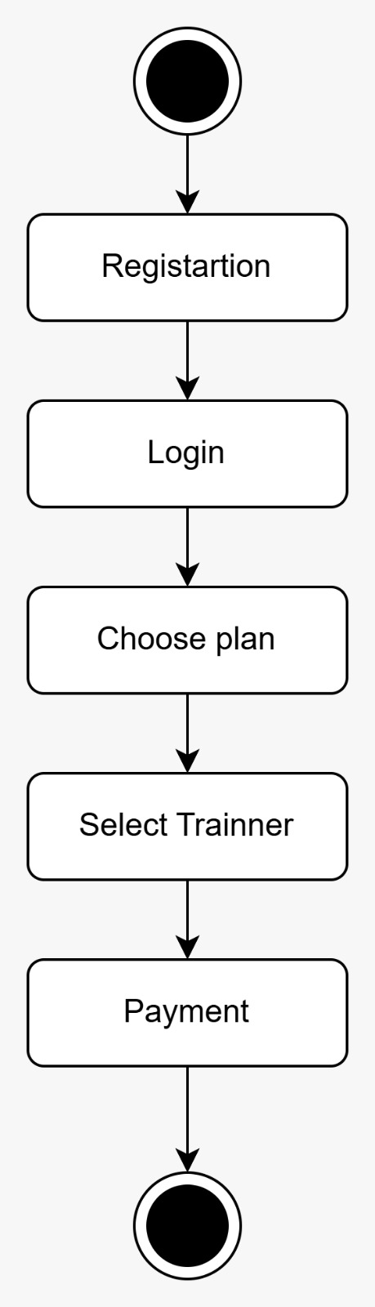

CLASS DIAGRAM –
